DAT-300 Project One
Karver Stockstill
Karver.stockstill@snhu.edu
Professor Pettit
Southern New Hampshire University

Preliminary Data
By addressing and understanding the questions: “Are there inventory trends that we should identify and monitor? Which months have sales increased? Which products produce the biggest revenue stream?,” can help the organization in understanding what items are creating a profit and prioritizing when restocking, how to increase sales in the low-performing months.
The data provided gives adequate information to help answer these questions. The data shows us categories that expand to include sub-categories which will show us any trends that occur. Also giving us data that includes the year and branches to quarters and months to help break down profit and sales margins. This data will assist in identifying the top-selling products as well as those with lower sales performance, enabling us to determine which items we should prioritize for promotion, and which should have a stable full inventory to maximize overall profitability.
Examination of Data
To answer these questions to the best of our ability, we will create visualizations that will focus on sales, profit, year, month, categories, and sub-categories. We must condense the data that we have to the data that we need to properly address the questions.
To understand the inventory trends, we can look at the categories involved in the data: furniture, office supplies and technology. Taking that data and comparing it in months to the total sales that occurred. We can see what categories are selling the most throughout the years.
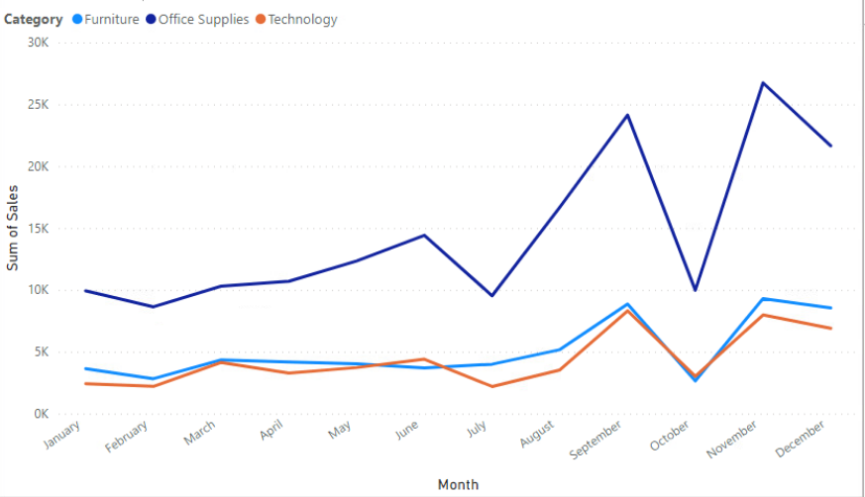
From the image above we can see that throughout the entire year office supplies outselling every other category by thousands of dollars. We can use this information to understand the inventory fluctuation that will help us keep certain items in stock while understanding what inventory may need to assess for optional promotional sales. Looking closely, we can see that the months of June, September and November gave us the most sales for office supplies; September and November producing high sales for both furniture and technology. With this information we can conclude that for those months we need to make sure that the inventory is full.
From this we can also see that for every category the month of October produced the lowest sales by showing a deep decline in the graphs. We can take this information and look more closely at the month of October to better understand why overall sales were at the lowest.
From the visualization below we took a closer look into the categories, looking into the subcategories and the profits that they produced throughout the year. It is very recognizable that binders and paper from the office supply category produced the most profit, aligning with the above data showing office supplies outselling every other category throughout the year. It is imperative that these two supplies maintain full stock to keep the maximum profit. Analyzing further we can see that furnishings from furniture as well as phones from technology produce the largest profit in their categories. Looking at the lowest profit, this consists of copiers and machines within the technology category. Inventory and placement of theses products can be something to investigate in finding a way to increase profit.
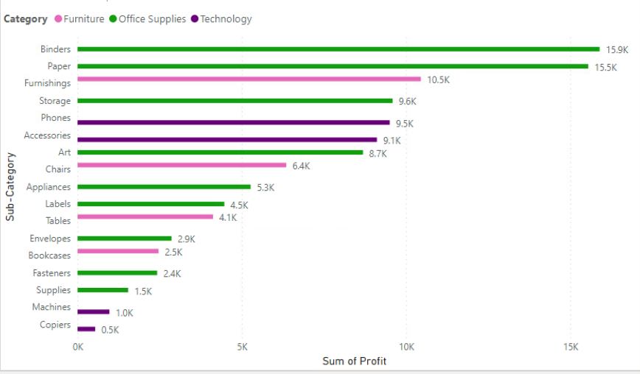
The image below provides a detailed analysis of revenue generated over the specified years. Office supplies consistently yield the highest revenue each year, demonstrating continual growth. Furniture maintains stable revenue levels, while technology persistently contributes the lowest annual revenue, indicating an area of concern.
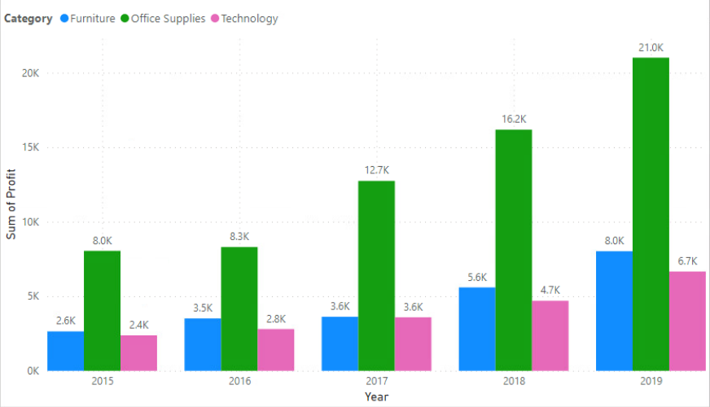
Data set completeness and accuracy
The provided dataset is complete and sufficient for addressing the organization's key questions, as it contains no missing data relevant to this analysis. It includes detailed information on sales, profit, quantity, categories, and sub-categories, which collectively offer comprehensive insights required for the evaluation. Data that is not relevant to these inquiries will have no significance during the review process.
Sales figures, profit margins, and product sub-categories serve as key indicators in identifying which products maintain a consistent stock and during which months. The availability of comprehensive data on monthly sales, profit, and revenue enables informed decisions regarding the most profitable products, thereby supporting effective inventory management and stability.
Data Retention
To address the organizational questions using the provided dataset, it is necessary to utilize the sales, profit, category, sub-category, year, and month columns. It is advisable to clean and organize the data before analysis. Creating a separate copy of the required columns ensures the integrity of the original dataset, allowing for future analyses or the accommodation of new inquiries. Maintaining proper data retention practices further safeguards against data loss due to accidental deletion or system failures, thereby ensuring that data recovery remains possible if needed (Geeks, 2024).

Data usage limitations
This analysis used only sales data—such as items sold, dates, and total profit—without any customer names, card numbers, or other sensitive information. The organization has entrusted us with their data, so we must follow ethical practices. Legally, it is important to know what is private, copyrighted, or licensed, understand privacy policies, obtain proper permissions, and check for licensing attached to the data (O’Brien et al, 2011).

Resources
Margaret O'Brien, Rebecca Lubas, Ruth Duerr, Todd Grappone, Trisha Cruse, DataONE. (01 September, 2011) "Best Practice: Sharing data: legal and policy considerations". https://dataoneorg.github.io/Education/bestpractices/sharing-data-legal
Geeks for Geeks. (22 May, 2024). What is Data Retention? https://www.geeksforgeeks.org/data-science/what-is-data-retention-and-how-does-it-decide-how-long-data-should-be-kept/

